QUOTATION:
INSTALLATION OF WATER PURIFICATION PLANT 
PROCESS DISCRIPTION
Filtration

The proposed filtration process is done via 3 stages and 3 chambers.
Filter 1: Anthracite Filter: (Silex + Fine Sand + Anthracite)
Removes suspended particles. The water passed through Anthracite will eradicate all the suspended particles in water. The Natural Anthracite used in this process is imported from Germany.
Filter 2: Birm Filter: (Silex + Birm)
Removes the dissolved Iron in the water. Birm used in this process is imported from USA.
Filter 3: Resin Filter:
Will fix the calcium and magnesium dissolved in the water. As per the test results, the present amount of Ca and Mg are high. This stage will res olve the same and neutralize the water.
The online filtration plant will be installed on the roof. The water will be pumped to the treated water collection tank through the filtration system using 1 HP Pump. Sand provided in the vessel is utilized to filter the sediments contained in the water. A combination of Anthracite, Silex and Fine granular sand are given as supporting base media. The water passing through all these media will be clear and free from iron, color, smell, sediments, etc

Back Wash

Provision is given in the filter for periodic manual back washing, which is necessary to make the media clean and its removes the dirt particles accumulated in the vessel. A clean surface of the media is imported in proper functioning of the system. The present operation of the pump can do perform this action automatically.
Option: Backwash can be done automatically on a periodic basis, when fitted with an Auto-backwash system. This is done on additional cost
How does a filter work?
A filter has three different operations that it performs. The head controls these functions and they are as follows:
Service - During service (filtration) the water is directed down through the filter media where the particles in the water are trapped. Once the water has reached the bottom of the tank, it returns to the top of the tank through the distributor.
Backwash - The head will determine when the system needs to be backwashed or regenerated based on elapsed time or water usage. During backwash the head will direct water down through the distributor and up through the media. This flow will be of enough force to actually lift the media and shake lose any trapped particles. The water that leaves the top of the tank is directed to the drain.
Rinse - Once the media has been backwashed, it is rinsed by again sending water down through the media and then to drain. This will rinse any lose material at the bottom of the bed and in the riser to drain. Once rinsed, the filter will return to service.
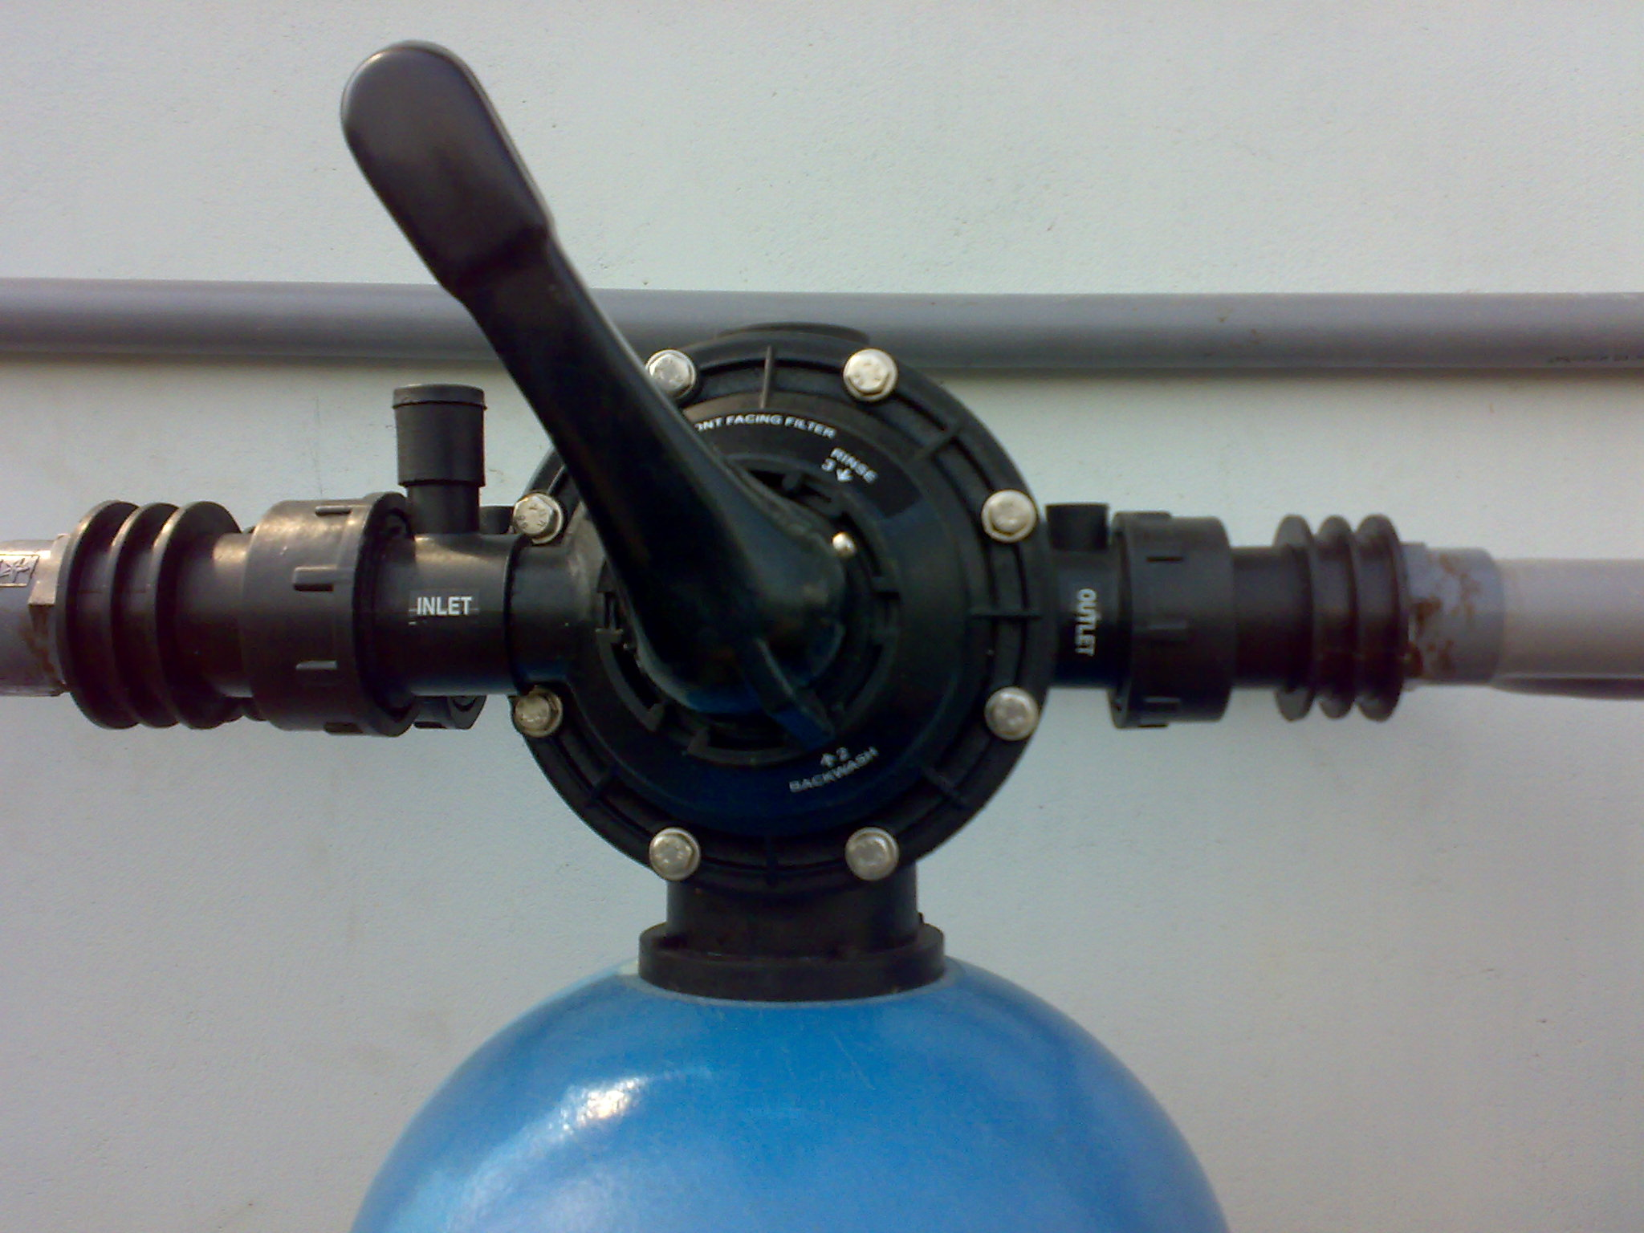
Iron Removal Water Filter

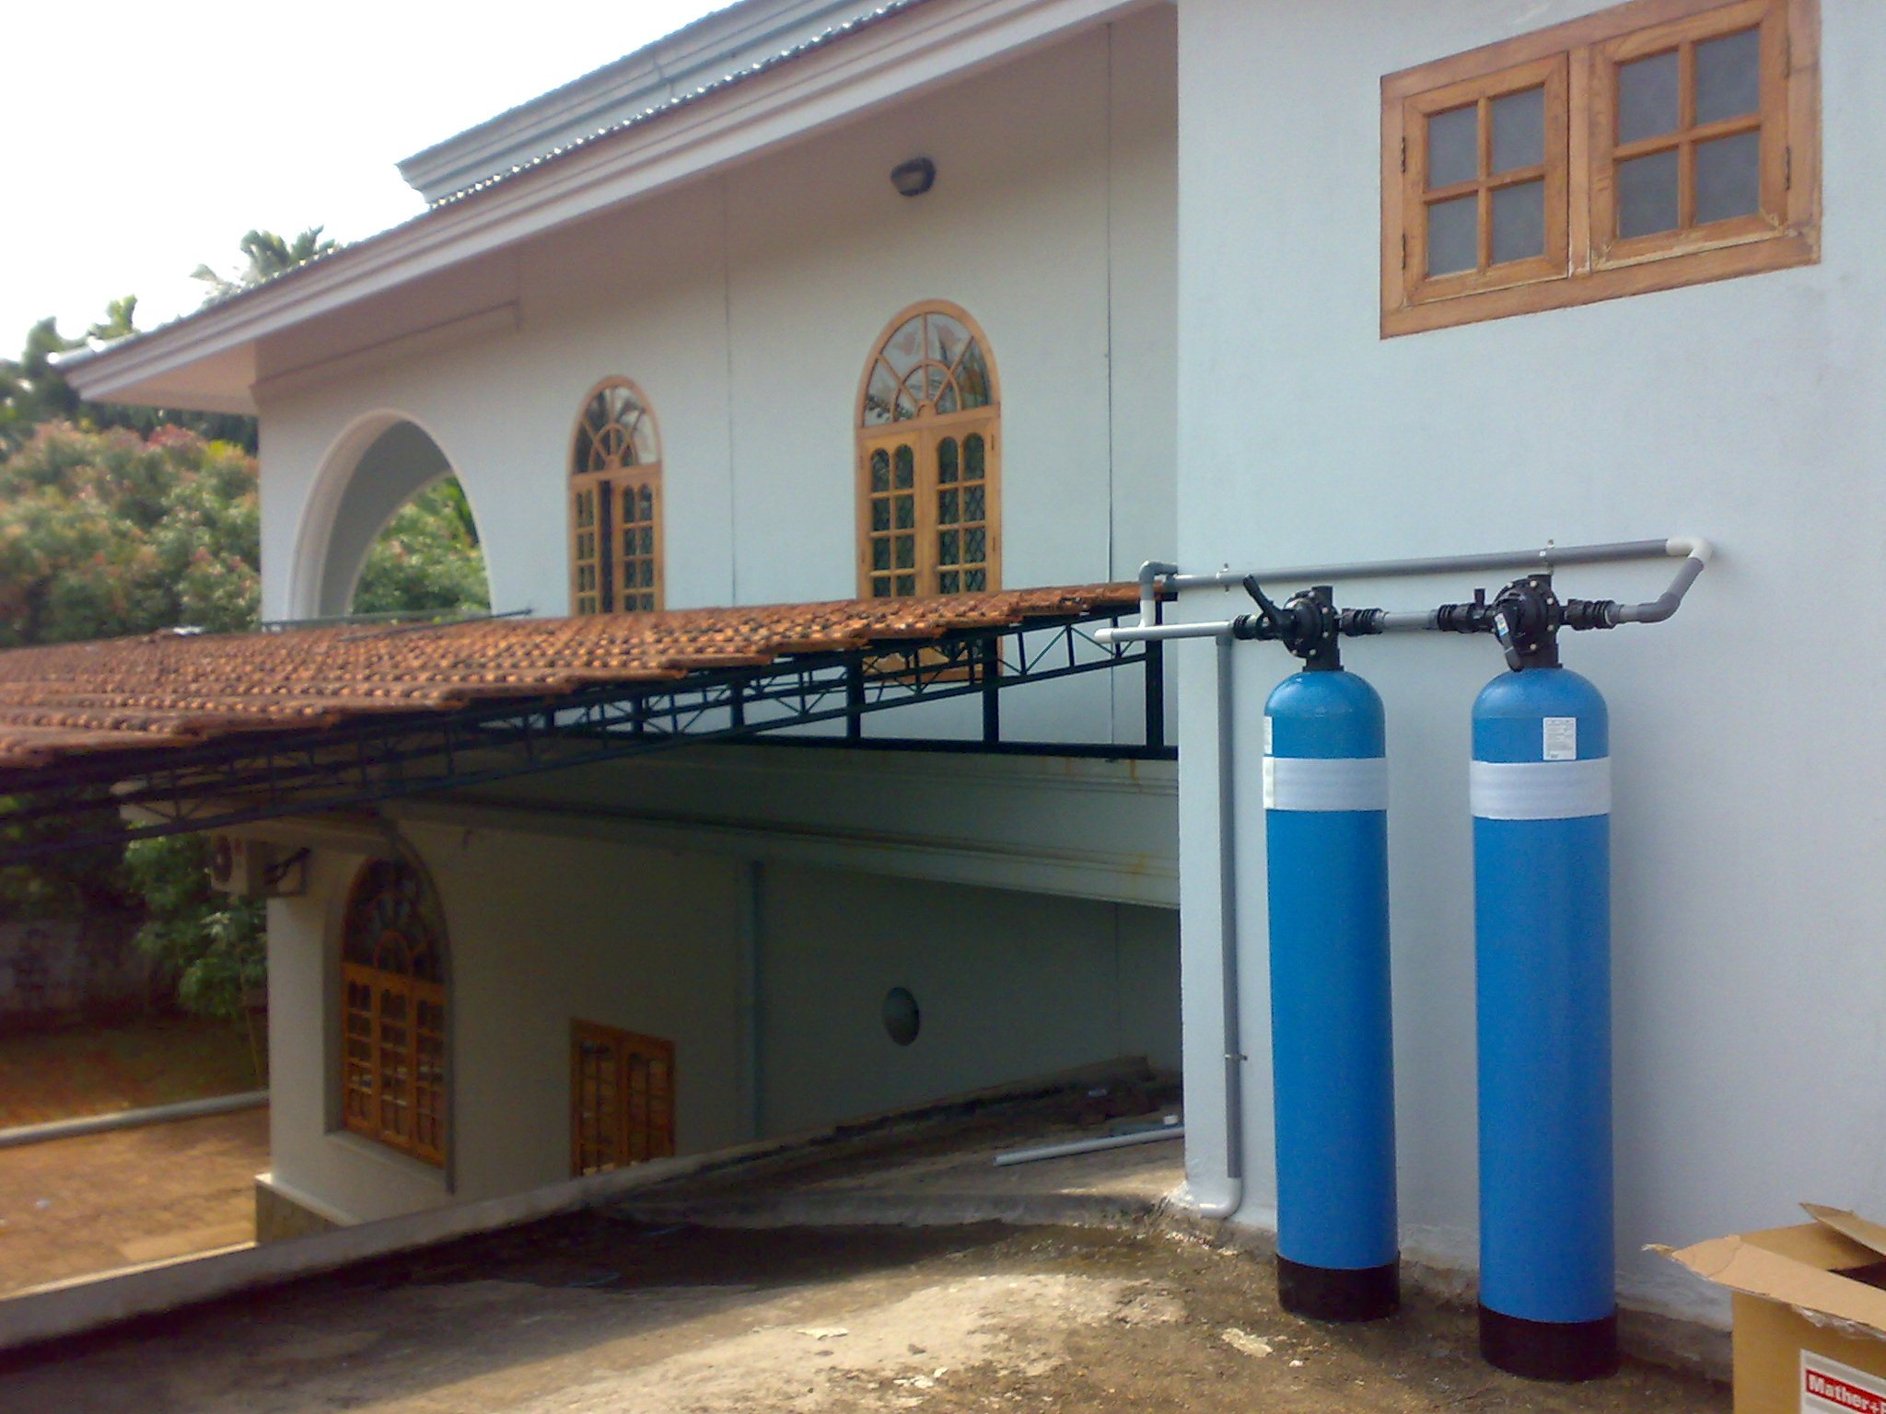

If your home's water supply has high iron, manganese or hydrogen sulfide content, you should consider the addition of a whole house iron / hydrogen sulfide reduction filter to your water treatment system. This filter contains manganese greensand which reduces these contaminants through an oxidation / filtration process, thereby substantially improving water clarity, taste, and odor, while at the same time protecting your plumbing system including toilets, bath tubs and showers, and appliances such as clothes washers and dishwashers from unsightly staining. It adds no harmful chemicals to the water, making it completely safe for drinking water applications. Iron and manganese reduction will also prolong the life of a reverse osmosis membrane if you have a point-of-use reverse osmosis system in your home. This filter should be installed on the main cold water line after the pressure tank or water meter. For best results, pre-sediment and post-carbon treatment is recommended.

Advantages:
Fraction of the cost of competitive reverse osmosis systems
Easy to installation and maintains !
Easy backwashing system!
Effective over a wide pH range
Prevents staining of laundry and plumbing system including you shower and tub
Relatively long filter life - cost effective long-term operation
Simple installation
radial flow design for high flow rates and extremely low pressure drop

Media details:-

Anthracite
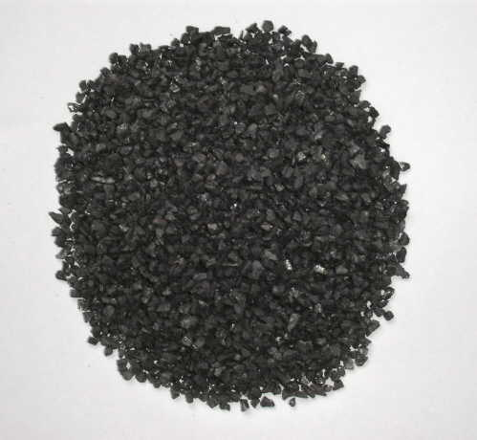
Commonly used as sub-fill and as a component of multi-media filters, anthracite is a durable media with long life and a wide temperature range. It contains no silica to interfere in the production of ultra pure water.
Used for turbidicity removal and solid filtration ,Size range: 0.150-62mm, Uniformity co-efficient (UC): 1.3-1.7, Custom sizes can be provided at request, Product meets AWWA Standards, NSF approved

Filter Sand and Gravel may also be called Torpedo Sand - Coarse Sand - Support Gravel - Filter Gravel - Pea Gravel ? The filter sand and gravel we stock and distribute is 99% silica and mined in New Jersey. The sub-angular shape of silica sand enhances the mechanical filtration properties of multi-media filters. It is a dense media at 100 pounds per cubic foot and acts as perfect sub-fill for non-silica sensitive applications such as water softeners and dealkalizers.

Birm? is a granular filter media commonly used for the reduction of iron and/or manganese from residential raw water supplies.

Filter Gravel
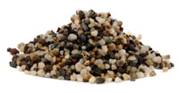
Size range: 1.6-64mm, Custom sizes can be provided at request, Product meets AWWA Standards, NSF approved

Calcite

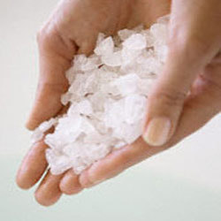
We provide our clients superior quality White Calcite, which is an excellent Water Treatment media. It is found naturally as calcium carbonate, and is widely used for its self-limiting property. On proper application, it does not correct the pH under normal conditions, but rectifies it just so that non-corrosive equilibrium may be reached. In the typical plumbing systems, copper, lead and other metals are found, therefore, by adding Calcite the calcium carbonate present in the acidic water is slowly dissolved which reduces the potential leaching.

DIAGRAMATIC REPRESENTATION OF FILTRATION SYSTEM

